**Hydroxyl Radical Reaction with Soil-Derived Water Extractable Organic Matter and Its Adsorptive Fractionation with Fe (oxy)hydroxide**

**Hydroxyl Radical Effects on the Chemical Composition of Soil-Derived Water Extractable Organic Matter and Its Adsorptive Fractionation with Fe (oxy)hydroxide**

Kaizad F. Patel, †⍑ Václav Tejnecký, ⅂ Tsutomu Ohno,*, † Thomas B. Parr, ‡ M. Susan Erich, ‡ Rachel L. Sleighter,§ and Patrick G. Hatcher§

† School of Food and Agriculture, University of Maine, Orono, ME, 00469-5722, U.S.A.

⍑Pacific Northwest National Laboratory, Biological Sciences Division, Richland, WA 99352, U.S.A.

⅂ Department of Soil and Soil Protection, Czech University of Life Sciences Prague, Prague, Czech Republic.

‡ Department of Biology, University of Oklahoma, Norman, OK, 73019, U.S.A.

§ Department of Chemistry and Biochemistry, Old Dominion University, Norfolk, VA 23529, U.S.A.

*Corresponding author: e-mail: ohno@maine.edu; phone 207-581-2975; fax 207-581-2999

**ABSTRACT**

**INTRODUCTION**

The global soil organic carbon (C) storage by temperate forest soils is estimated to be 195 Pg of C to a depth of one meter.1 The inputs of carbon from the forest floor to the mineral soil horizons is primarily in the dissolved organic matter (DOM) transported downward from the O-horizon layer. The fate of the DOM depends on its potential biotic and abiotic interactions with soil components. DOM can be biodegraded by the soil microbial community and incorporated into biomass or returned to the atmosphere as CO2.2 DOM adsorbed to metal (oxy)hydroxide surfaces have been shown to have reduced bioavailability in laboratory incubation studies.3-5 Recent research has suggested that the organic matter-mineral interaction is the dominant factor in the stabilization of soil organic matter.6-8 This finding has driven researchers to obtain a better understanding of the chemical process driving the interaction of DOM with mineral surfaces. The ultrahigh resolution capabilities of Fourier transform ion cyclotron resonance mass spectrometry (FT-ICR-MS) have shown in numerous studies that aromatic and aliphatic molecules with high O/C atomic ratios have high affinity for FeOOH and Al2O3 mineral surfaces.9-13 Studies that combined the use of atomic force microscopy (AFM) and FT-ICR-MS showed that higher molecular weight carboxyl-rich aromatic and N-containing aliphatic DOM molecules were correlated with high binding forces between DOM and iron (oxy)hydroxide functionalized AFM tips.14,15 These cited studies clearly show that adsorptive fractionation of DOM is occurring on the mineral surfaces with in the enrichment of DOM components with higher affinity on the metal (oxy)hydroxide surface and those with lower affinity towards the mineral surfaces remaining in solution. The AFM studies provide strong support for the layer-by-layer “onion” model of DOM structuring where carboxylic-rich aromatic and N-containing aliphatic molecules are initially involved in the DOM adsorption process.

With adsorption to the mineral surface being a critical step in the stabilization process of soil C, soil processes that affect the chemical composition of DOM is likely to affect the persistence of soil C. FT-ICR-MS studies have consistently shown that lignin-like class of DOM molecules make up the dominant fraction DOM.16-20 Furthermore, lignin-derived organic matter has recently been shown to undergo aerobic abiotic oxidation by reactive oxygen species through a series of reaction steps. The steps include: 1) the loss of methoxy groups, 2) the oxygenation of aromatic rings, 3) ring opening to form carboxylated olefins, 4) condensation to cyclic structures, and 5) radical-induced proton scavenging to form either carboxylated aromatic observed in soils or carboxylated alicyclic molecules. 21-23 Recently, Whendee Silver’s group has published a series of elegant papers on the role of iron in the decomposition of lignin and soil organic matter based on soils from a humid tropical forest in Puerto Rico, which experiences warm temperatures and frequent precipitation leading to repeated fluctuations in soil redox potential. They demonstrated the production of reactive oxygen species from the oxidation of Fe(II) in soils.24 They showed that fluctuating levels of soil O2 drove soil Fe redox reactions generating reactive oxygen species that led to increased lignin biodegradation.25 A laboratory soil incubation study with Fe(II) addition showed that Fe(II) addition disproportionately reduced the mineralization of lignin, independent of O2 availability.26 In addition, drier upland soils from diverse ecosystems also have high iron reduction potential that could affect iron-coupled processes such as lignin decomposition in non-tropical ecosystems.27

The hydroxyl radical (·OH) is a powerful oxidant that can be generated in soils through the Fenton reaction28: H2O2 + Fe2+ ⟶ ·OH + OH- + Fe3+. In soils, the H2O2 can come from rainwater which average 2~40 µmol L-1 H2O2 29 or through *in situ* oxidation of Fe2+ and reduced DOC by O2.30 Climate-induced increases in both frequency and intensity of precipitation events31 is likely to affect the frequency of soil redox cycling as soils undergo more rapid and intense wet-dry cycles. Understanding these dynamic soil processes will be increasingly important for understanding ecosystem services such as the decomposition of soil organic matter and stabilization of soil C associated with redox-active soil processes. The effects of reactive oxygen species (ROS) on lignin-derived DOM and aquatic DOM have been extensively investigated,21-23, 32,33 however studies ROS effects on soil-derived DOM have been limited. To address this knowledge gap, the effects of ·OH on the chemical composition of DOM extracted from the O-horizon from deciduous (DEC) and coniferous (CON) forest stands were investigated using FT-ICR-MS and solid-state 13C NMR analysis. Additionally, an adsorption experiment was conducted using FeOOH to determine how the Fenton oxidation of DOM impacts its interaction with FeOOH.

**EXPERIMENTAL SECTION**

**Dissolved Organic Matter and Reaction with ·OH Radical.** The organic O-horizon soils were collected from the DEC and CON stands in the reference watershed of the Bear Brook Watershed in Maine (44°52'′ N, 68°06′ W), U. S. A.34 The two soils were extracted in triplicate with deionized distilled water (DI-H2O) at a 1:10 soil:DI-H2O (w:v) ratio for 16 h at 4 °C, centrifuged, and vacuum filtered through a 0.4 µm polycarbonate filter. The dissolved organic carbon (DOC) concentration of the extract was measured using a Shimadzu TOC-V analyzer. A portion of each was retained to serve as the reference DOM prior to the oxidation and adsorption to FeOOH treatments. The DOM oxidation treatment used OH· radicals produced from the Fenton reaction (Waggoner et al., 2015). Briefly, the DOM solution of ~300 ppm dissolved organic carbon (DOC) was adjusted to pH 3 and 4 mg of FeSO4**·**7H2O were added to the solution. The OH· species formation was initiated by adding 2 mL of 30% H2O2 and allowed to react for 1 h prior to characterization by NMR and mass spectrometry.

**Solid State 13C NMR Analysis.** The extracts were frozen and then freeze-dried for the NMR analysis. Solid-state 13C NMR experiments were performed by a double resonance technique on a Bruker Advance II spectrometer with 1H resonating at 400 MHz and 13C resonating at 100 MHz. The NMR was equipped with a 4mm H-X magic angle spinning probe head. The 13C chemical shifts were calibrated to a glycine external standard (176.03 ppm). Quantitative 13C NMR spectra with a multi-CP (cross polarization) pulse program have been shown to be comparable to direct polarization NMR experiments but with greater S/N (Johnson and Schmidt-Rohr, 2014). Samples of approximately 80 mg were packed into zirconium rotors and sealed with Kel-F caps for analysis. Acquisition parameters were optimized per sample using the multi-CP approach, acquiring 5008 scans and a magic-angle spinning rate of 14 kHz.

**ESI-FT-ICR-MS Analysis.** The extracts were processed through Agilent PPL solid-phase extraction cartridges to desalt the extract for subsequent electrospray ionization (ESI) FT-ICR-MS analysis.35 The DOM was characterized using negative ion mode ESI with a 12 T Bruker Daltonics Apex Qe FT-ICR-MS instrument at the COSMIC facility at Old Dominion University. To increase the ionization efficiency, ammonium hydroxide was added immediately prior to ESI to raise the pH to 8. Samples were introduced by a syringe pump at an infusion rate of 120 µL h-1 and analyzed in negative ion mode with electrospray voltages optimized for each sample. Ions (in the range of 200-2000 m/z) were accumulated in a hexapole for 1.0 sec before being transferred to the ICR cell. Exactly 300 transients, collected with a 4 MWord time domain, were added for a total run time of ~ 30 min. The summed free induction decay signal was zero-filled once and Sine-Bell apodized prior to fast Fourier transformation and magnitude calculation using the Bruker Daltonics Data Analysis software. Prior to data analysis, all samples were externally calibrated with a polyethylene glycol standard and internally calibrated with naturally present fatty acids within the sample.

**Mass Spectra Data Post-Processing.** For assignments of molecular formulas, peaks with a signal to noise ratio above 5 were assigned using the formula extension approach.36 A MATLAB script was used to parse the assigned formulas into the appropriate van Krevelen space, which consisted of six discrete regions 37: 1) condensed aromatic molecules (AImod > 0.66); 2) aromatic molecules (0.66 ≥ AImod > 0.50); 3) highly unsaturated molecules (AImod ≤ 0.50 and H/C < 1.5); 4) saturated molecules (Sat, H/C ≥ 2.0 and O/C ≥ 0.9.); 5) non-N containing aliphatic molecules (2.0 > H/C ≥ 1.5); and 6) N containing aliphatic molecules (2.0 > H/C ≥ 1.5). The DBE value is the sum of double bonds and rings in a molecule that characterizes the degree of unsaturation in a molecule based on C-C double bonds and rings and is independent of the number of O and S in the formula. The DBE values were calculated as 1 + ½(2C-H+N+P).38 The modified aromaticity index (AImod) was calculated as (1+C-½O-S-½H)/(C-½O-S-N-P).39 The AImod value accounts for the capability of heteroatoms found in organic matter molecules to form double bonds, and this modified index assumes that all O atoms are present as carboxyl groups. The nominal oxidation state of carbon (NOSC) was calculated using the formula: NOSC = 4 – [(4c + h – 3n -2o -2s)/c]

where c, h, n, o, s refer to the stoichiometric numbers of C, H, N, O, and S atoms per formula, respectively. Further post-processing details can be found elsewhere.40 To provide a rigorous evaluation of the oxidation and adsorption treatments, an R script was used to identify assigned formulas present in all three replicates of the treatment WEOM solutions to be included into the data analysis.

**Adsorption Experiments.** Batch DOM adsorption studies were conducted in triplicate using catalysis-grade FeOOH purchased from Sigma-Aldrich (#371254) and used after repeated rinsing with DI-H2O. A suspension of 1.00 g FeOOH in 30 mL of DOM solution in glass Erlenmeyer flasks was shaken on an orbital shaker for 48 h at 4° C. Controls were established with DI-H2O plus the FeOOH. The solutions were then filtered and analyzed for their DOC concentrations as described above. The quantity adsorbed was calculated by difference from the initial DOC solution concentration.

The S/N ratio method was used to identify DOM molecules that were adsorbed and not adsorbed by FeOOH was adopted in this study.41 The minimum intensity value of the peaks assigned represents formulas at the selected threshold S/N = 5. Assigned formulas with greater than two times the minimum intensity value were designated as having an S/N > 10. Adsorbed DOM molecules were defined as formulas with S/N > 10 in the pre-adsorption solution and S/N < 5 (i.e., not detected) in the post-adsorption solution. Non-adsorbed molecules were defined as formulas with pre-sorption S/N > 10 and post-adsorption solution S/N > 5.

**RESULTS AND DISCUSSION**

Table 1. WEOC concentrations.

|  |  |  |  |
| --- | --- | --- | --- |
|  | HW | SW | p-value |
| Initial | 513 ± 12 mg/L | 656 ± 13 |  |
| Post-Fenton | 499 ± 9 | 640 ± 16 |  |
|  | P = 0.16 | P = 0.08 |  |

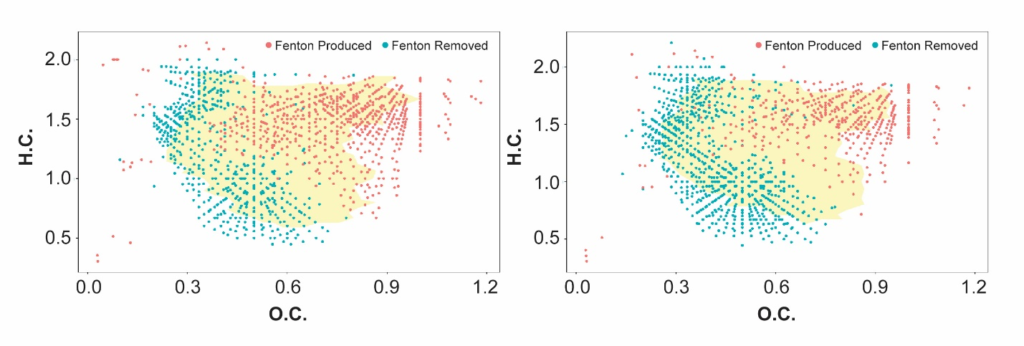 **Fig. 1.** van Krevelen diagram of the formulas lost and newly formed by the Fenton ·OH oxidation of the deciduous and coniferous DOM extracts. The yellow background region represents the space occupied by conserved formulas as defined by the ‘alphahull’ shape script.



**·OH Oxidation Effects on Extract DOC Concentration and Composition.**

The chemical composition of DOC extracts was substantially altered by the Fenton reaction for both DEC and CON soils (Figure 1), although the concentrations did not differ significantly between pre- and post-Fenton extracts (Table 1). This indicates that our one-hour Fenton treatment likely resulted partial oxidation of the DOM components, rather than complete oxidation to CO2.Molecules with lower O/C ratios in the aliphatic, polyphenol, and condensed aromatic regions were preferentially lost, whereas the newly formed molecules generally had H/C > 1.0 and O/C > 0.5 (**Fig. 1A&B**). Our results suggest that oxidation is likely to impact DOM reactivity with soil components due to greater oxygen-containing functional group content after Fenton oxidation. The van Krevelen diagrams also show that that there was a high degree of similarity for the DEC and CON extracts in the van Krevelen space where the lost, conserved, and newly formed formulas occupied stand vegetation does not strongly affect DOM chemical composition. This was confirmed by the sharing of 415 (45.8%) of the 907 unique formulas between the two DOM extracts for those lost in the oxidation treatment, and the sharing of 348 (45.9%) of 758 unique formulas for the newly formed formulas.

The impact of ·OH oxidation on the DOM chemical composition is shown by intensities of pre- and post-Fenton DOM as a function of the number of O atoms in their formula (**Fig. 2**). The plot suggests that the ·OH radical reaction is preferentially consuming DOM molecules with ≤ 7 O atoms and forming new molecules with > 15 O atoms. At the 8 O atom threshold, the total cumulative intensity was reduced from 58% to 4.8% for the DEC extract and 50% to 4.9% for the CON extract. The changes in DOM chemical composition were further investigated by calculating descriptive chemical parameters and magnitude-weighted relative content of six classification groups derived from the van Krevelen diagrams (**Table 1**). The patterns of change in the chemical indices were similar for both DEC and CON DOM extracts so averages will be used to contrast the consumed and newly formed molecules. The average C number in the molecule decreased from 21.7 to 19.1 which was statistically (p = 0.012) different using the t-test and the average O number significantly (p=0.007) increased from8.8 to 13.9. Thus, the O/C ratio was significantly (p = 0.002) higher for the newly formed molecules, 0.76, as compared for the molecules lost in the oxidation reaction, 0.42.

The VKD diagrams suggests that the ·OH radical reaction consumed aliphatic, aromatic and condensed aromatic molecules, while the newly formed molecules were predominately in the carbohydrate-region (**Fig. 1A & B**). The intensity-weighted relative distribution of the VKD defined chemical classification groups for the consumed and new formulas are shown in **Fig. 3**. Averaged across the DEC and CON DOM, the pre-Fenton



**Fig. 2.** The percentage of total intensity for the lost and newly formed formulas binned by the number of oxygen atoms for the ·OH oxidation treatment of (A) deciduous and (B) coniferous DOM extracts. The dashed lines represent the total fractional cumulative intensity as a function of oxygen number. The intensity of the newly formed formulas are expressed a negative value to clearly allow comparison of the two pools.

**Table 1.** Effect of Fenton oxidation on the percent relative distribution of van Krevelen diagram derived classifications of formulas consumed, conserved, and generated for the deciduous and coniferous DOM extracts.

|  |  |  |  |  |  |  |  |
| --- | --- | --- | --- | --- | --- | --- | --- |
| **DOM Type** | **Formula Type** | **Average Formula** | **H/C** | **O/C** | **m/z** | **DBE/C** | **NOSC** |
| DEC | Consumed | C21.4H26.3O8.5N0.84S0.01P0.01 | 1.24 | 0.41 | 430.4 | 0.451 | -0.286 |
|  | Conserved | C19.8H25.7O10.2N0.31S0.02 | 1.30 | 0.53 | 430.8 | 0.411 | -0.184 |
|  | New | C19.2H28.1O13.6N0.53S0.04P0.01 | 1.47 | 0.74 | 478.6 | 0.335 | 0.100 |
|  |  |  |  |  |  |  |  |
| CON | Consumed | C21.9H27.0O9.1N0.62S0.02P0.02 | 1.24 | 0.42 | 445.1 | 0.447 | -0.288 |
|  | Conserved | C19.5H26.5O10.4N0.22S0.01P0.01 | 1.36 | 0.54 | 421.5 | 0.381 | -0.229 |
|  | New | C18.9H29.0O14.2N0.33S0.07P0.01 | 1.55 | 0.77 | 489.1 | 0.295 | 0.060 |

|  |  |  |  |  |  |  |
| --- | --- | --- | --- | --- | --- | --- |
|  | **CondAr** | **Aromatic** | **Lignin** | **Carb** | **Aliphatic** | **Peptide** |
| **HW** |  |  |  |  |  |  |
| **% initial** |  |  |  |  |  |  |
| **% Intensity lost** | 0.71 | 8.02 | 60.95 | 2.39 | 22.32 | 5.61 |
| **% Intensity conserved** | 0.00 | 0.04 | 76.19 | 8.98 | 12.08 | 2.71 |
| **% Intensity new** | 3.00 | 0.32 | 40.34 | 52.04 | 2.62 | 1.68 |
|  |  |  |  |  |  |  |
| **SW** |  |  |  |  |  |  |
| **% initial** |  |  |  |  |  |  |
| **% Intensity lost** | 0.39 | 6.40 | 61.69 | 2.01 | 23.92 | 5.59 |
| **% Intensity conserved** | 0.03 | 0.16 | 69.27 | 7.56 | 20.40 | 2.57 |
| **% Intensity new** | 1.98 | 0.35 | 32.89 | 59.33 | 2.59 | 2.86 |

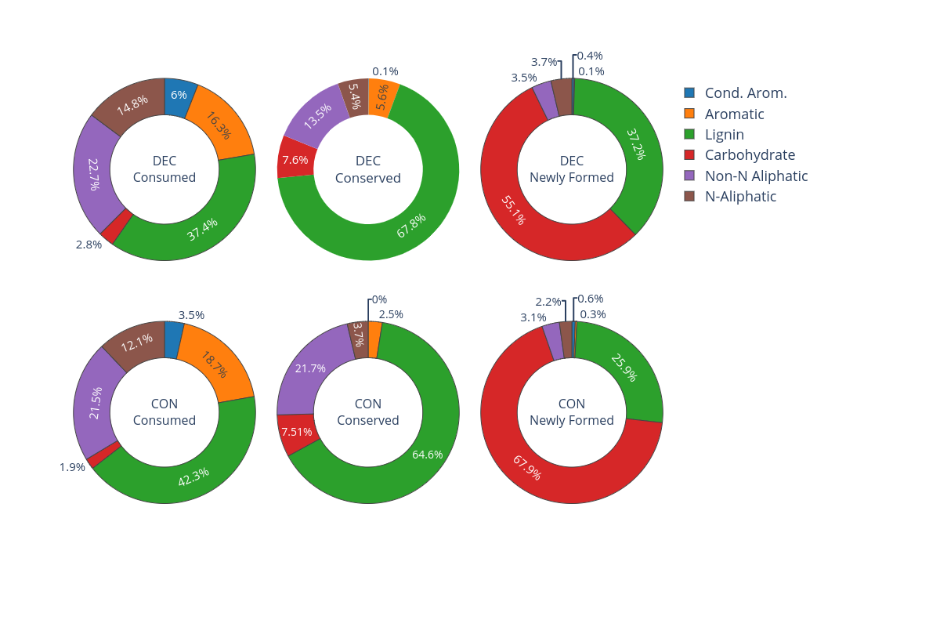

Fig. 3. Percent relative distribution of van Krevelen diagram derived classification groups of the formulas consumed, conserved, and newly formed for the deciduous and coniferous DOM extracts.

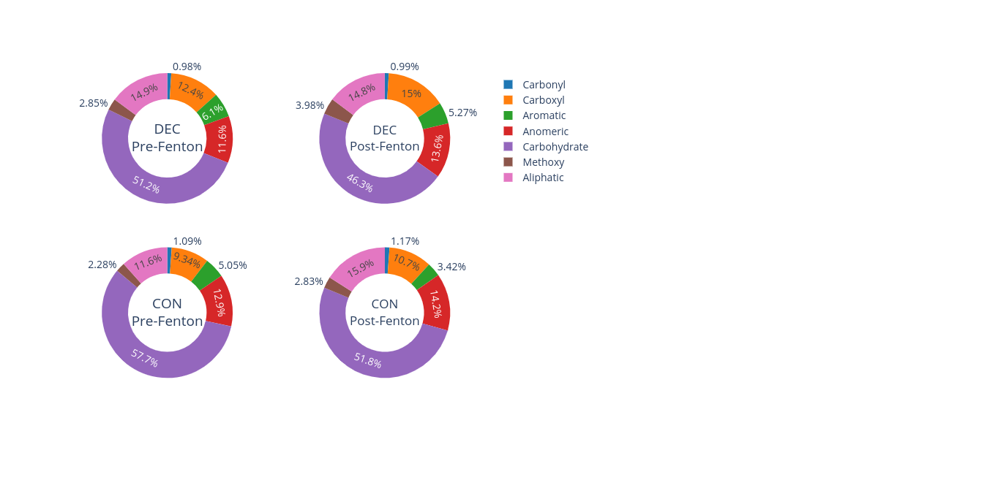

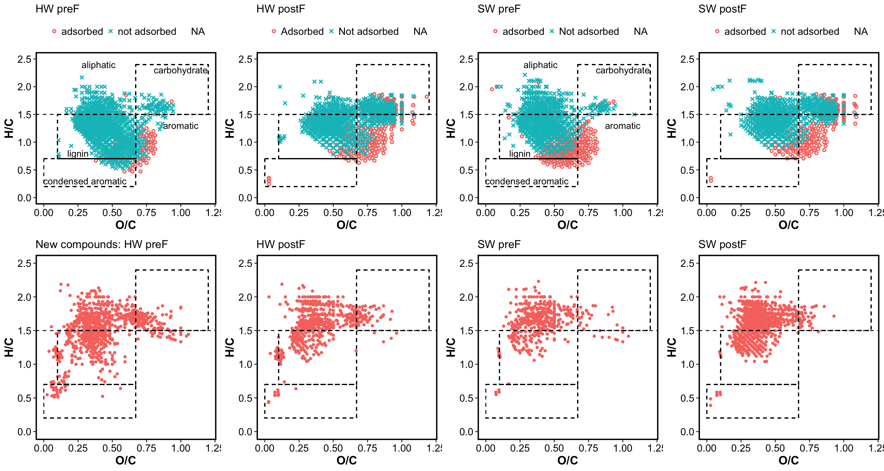



**REFERENCES**

Dittmar, T.; Koch, B.; Hertkorn, N.; Kattner, G. A simple and efficient method for the solid-phase extraction of dissolved organic matter (SPE-DOM) from seawater. *Limnol. Oceanogr-Meth.* 2008, 6, 230-235.

Kujawinski, E. B.; Behn, M. D. Automated analysis of electrospray ionization fourier-transform ion cyclotron resonance mass spectra of natural organic matter. *Anal. Chem*. 2006, 78, 4363-4373.

Seidel, M.; Beck, M.; Riedel, T.; Waska, H.; Suryaputra, I. G. N. A.; Schnetger, B.; Niggemann, J.; Simon, M.; Dittmar, T. Biogeochemistry of dissolved organic matter in an anoxic intertidal creek bank. *Geochim. Cosmochim. Acta* 2014, 140:418-434.

Koch, B. P.; Dittmar, T. From mass to structure: An aromaticity index for high-resolution mass data of natural organic matter. *Rapid Commun. Mass Sp*. 2006, 20, 926-932.

Hertkorn, N.; Benner, R.; Frommberger, M.; Schmitt-Kopplin, P.; Witt, M.; Kaiser, K.; Kettrup, A.; Hedges, J.I. Characterization of a major refractory component of marine dissolved organic matter. *Geochim. Cosmochim. Acta* 2006, 70, 2990-3010.

Ohno, T.; Ohno, P. E. Influence of heteroatom pre-selection on the molecular formula assignment of soil organic matter components determined by ultrahigh resolution mass spectrometry. *Anal. Bioanal. Chem*. 2013, 405, 3299-3306.

Avneri-Katz, S., Young, R.B., McKenna, A.M., Chen, H., Corilo, Y.E., Polubesova, T., Borch, T., Chefetz, B., 2017. Adsorptive fractionation of dissolved organic matter (DOM) by mineral soil: Macroscale approach and molecular insight. Org. Geochem., 103, 113-124.

Norton, S.; Kahl, J.; Fernandez, I.; Haines, T.; Rustad, L.; Nodvin, S.; Scofield, J.; Strickland, T.; Erickson, H.; Wigington, P.; Lee, J. The Bear Brook Watershed, Maine (BBWM), U. S. A. Environ. Monit. Assess. 1999, 55, 7−51.